Clinical psychologist studies psychedelic drugs to treat PTSD in veterans
November 11, 2024Psychedelics, PTSD, SSRIs, Veterans
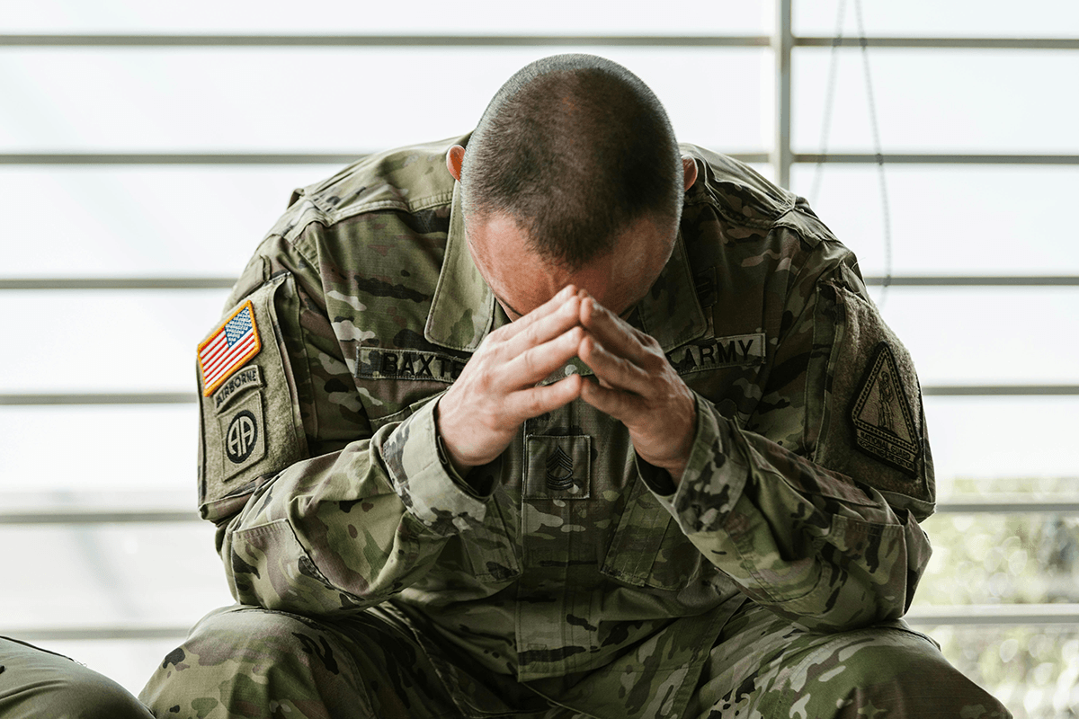
Many veterans experience traumatic events in service, seeking treatment for post-traumatic stress disorder (PTSD) and other mental health issues, including depression, anxiety and suicidality. While currently available medications and therapies work for some, many do not find sufficient benefit and require other forms of treatment. Researchers are studying the effects of psychedelics on PTSD among veterans to improve their symptoms and overall quality of life, including Dr. Lynnette Averill, associate professor in the Menninger Department of Psychiatry and Behavioral Sciences at Baylor and clinical research psychologist at the Michael E. DeBakey VA Medical Center.
Averill’s work focuses on research to eventually provide psychedelic-assisted therapy to veterans suffering from the effects of PTSD and related stress- and trauma-related symptoms. Her past observational studies included special operations forces veterans that were extremely trauma exposed.
“The rate at which people feel better and the robust nature in which people find significant improvement in symptoms is really exciting,” she said.
Previous studies included veterans with PTSD symptoms that tried different avenues for treatment, such as VA medical centers, private community care, medications, talk therapy and traumatic brain injury clinics. Some find no improvement or feel worse after taking SSRIs, which can pose challenges and negative side effects. SSRIs, or selective serotonin reuptake inhibitors, are medications to treat depression, anxiety and other psychological conditions. The only two existing medications with FDA approval specifically for PTSD are SSRIs. It can take weeks or months for people to feel better from taking SSRIs or engaging in talk therapy, and while these are lifesaving options for some, many do not respond or respond partially.
“The long delay from treatment initiation to potential therapeutic benefit is especially concerning as this is a significant challenge for patients and can include a heightened risk for suicidal thoughts and behaviors, substance misuse as a means of self-medication and other self-destructive behaviors,” she said.
In the studies with special operations forces veterans, Averill notes, “Psychedelic intervention generally lasts three to four days with some prep beforehand. To go for three to four days and have a significant shift in symptoms is in many cases lifesaving. It can work in hours to days.”
She clarified that most of the clinical trials being conducted across the world are not quite as abbreviated over three to four days yet are generally offering between just one and three doses of a psychedelic medicine in conjunction with psychological support before, during and after the drug administration. “While these are resource-heavy up front, they are generally briefer than other forms of intervention with much more rapid-acting and robust improvements. Across the board, the findings have been really promising.”
According to Averill based on her research, people who have even an average or mediocre response to psychedelic intervention experience improvements across PTSD symptoms like depression, anxiety, substance use and cognitive impairment, which is critical. Some reported the improvement in quality of life, stating the intervention gave them a sense of meaning, purpose and connection to themselves, others and the world around them, as well as shifts in critical areas relating to trauma exposure like moral injury, guilt and shame.
“It is so critical to feel like you have meaning, purpose and value in the world; that people care about you and that you have some connection, and that you’re part of something greater,” she said. “It is such an important piece for healing.”
Others report improved psychological flexibility, which helps with problem solving, decision making and seeing alternatives. When stuck in a place of suicidality, it is important to have the psychological flexibility to say, “Things are not good right now, and there may be hope and options.” While psychedelic intervention affects everyone differently, those who respond positively seem to have a better foundation to continue working to build a life they want to live.
Risks and side effects can develop from any medication, and psychedelic side effects vary from drug to drug. Psychedelics can increase cardiovascular risks as they elevate the heart rate and blood pressure. Those with uncontrolled hypertension or cardiac arrythmia might not be appropriate candidates for psychedelics to treat PTSD. Psychedelics might cause anxiety, paranoia or panic due to the intense experience and the body’s response.
Psychedelics are schedule 1 drugs. Generally, the only way to access these interventions legally in the U.S. currently is through clinical trials. Clinical trials provide safety and qualified individuals to support patients and administer the drug. They should not be used recreationally and should always be administered by a professional in a clinical setting.
“Risks from psychedelics should not generally be an issue in a clinical trial as there is careful screening and monitoring, precise dosing and consistent, specific clinical grade drugs; however, when used recreationally in underground settings, there can be major risks, like taking MDMA and getting hyperthermia, where the body gets overheated internally. People have died from it with recreational use,” Averill said. “Depending on the drug and other things a person may be using at the time, like alcohol or other drugs, physical health concerns, anxiety and feeling distressing thoughts and memories can occur.”
Averill stresses that it is critical that people advocate for their safety and wellness when enrolling in a trial. People must do their due diligence and understand the risks, safety plans and procedures for the setting. They should ask themselves why they are seeking this treatment and ensure they have trusted people to support them.
While psychedelic research comes with barriers and challenges, Averill looks forward to the future. She and a team of researchers at Baylor and the Menninger Clinic will begin enrolling patients for the Texas state-funded trial for psilocybin-assisted therapy for veterans with PTSD. She also will serve as the principal investigator for a multi-center phase 3 trial exploring psilocybin-assisted therapy for major depressive disorder, and she awaits funding for other studies with the VA and DoD. While she is passionate about improving the lives of veterans, she notes that many populations desperately need alternative interventions for traumatic experiences such as assault, abuse, natural disasters or car accidents.
“In mental healthcare, we are often able to save a life, which is a huge win. However, in many cases, this saving a life gets people only to the point that they are willing to tolerate existence and are not actively trying to find a way to end their life today. We must take the ‘leave no stone unturned’ approach to identify and develop novel, rapid-acting interventions, like psychedelic-assisted therapies, that have potential to fill this critical need for so many and can provide a safe, effective and durable foundation from which people can build lives they truly want to live,” she said.
Averill co-directs the Ethical Legal Implications of Psychedelics in Society Program (ELIPSIS) with Dr. Amy McGuire and is clinical director of the Emerge Research Program. She also serves as the director of research for The Menninger Clinic.
To learn more about ongoing and upcoming studies, email emerging@bcm.edu .
By Homa Warren

